<html>

<head>

<style>

table,th,td{border:1px solid black;}

</style>

</head>

<body>

<table>

<tr>

<th>class</th>

<th>name</th>

</tr>

<tr>

<td>meenu</td>

<td>3rd year</td>

</tr>

</table>

</body>

</html>

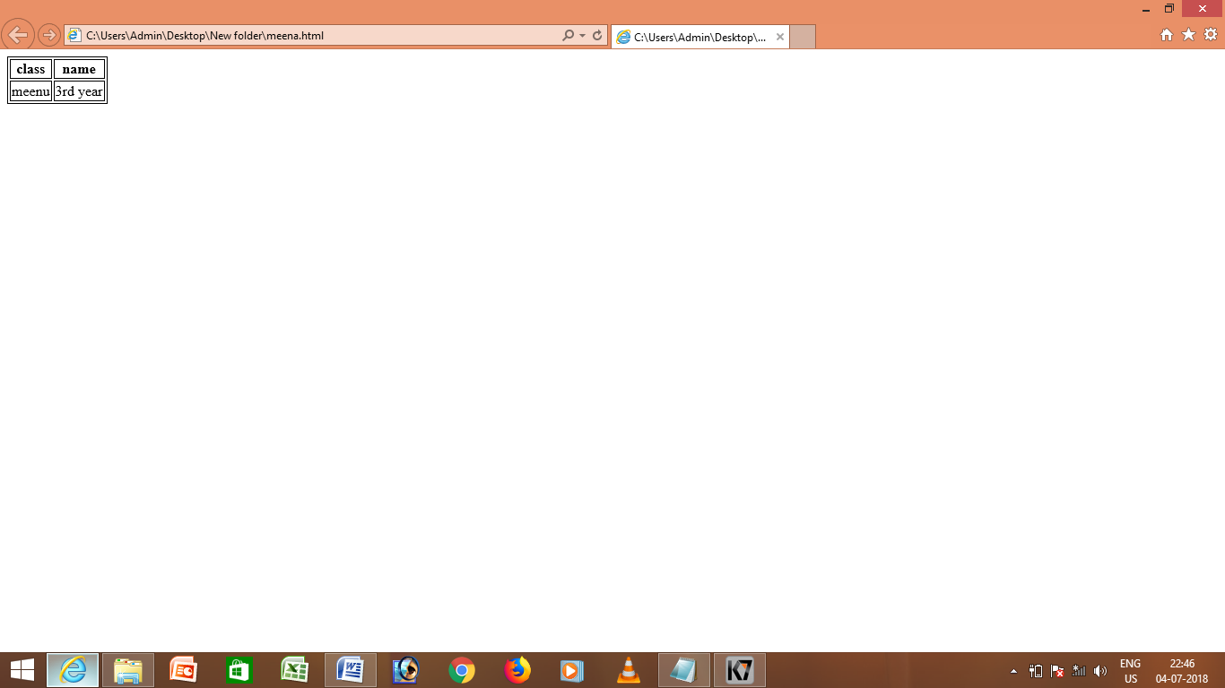

<html>

<head>

<style>

table,th,td{border:1px solid black;}

</style>

</head>

<body>

<table bgcolor="pink">

<tr>

<th>class</th>

<th>name</th>

</tr>

<tr>

<td>meenu</td>

<td>3rd year</td>

</tr>

<tr>

<td>swetha</td>

<td>3rd year</td>

</tr>

</table>

</body>

</html>

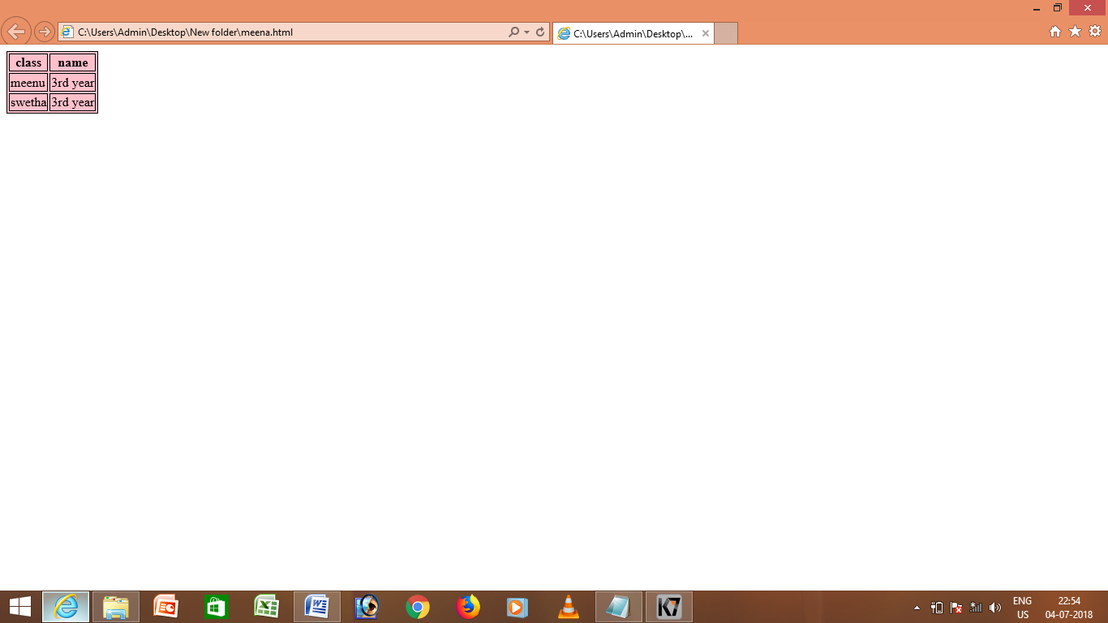

<html>

<head>

<style>

table,th,td{border:1px solid black;}

</style>

</head>

<body>

<h1> class student mark</h1>

<table>

<tr>

<th>name</th>

<th>mark</th>

</tr>

<tr>

<td>meenu</td>

<td>90</td>

<td> 89</td>

</tr>

</table>

</body>

</html>

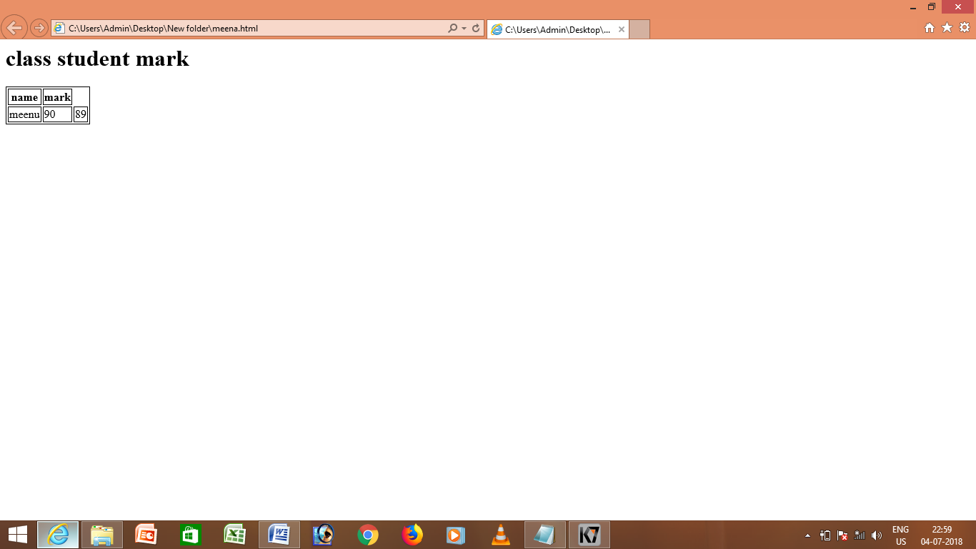

<html>

<head>

<style>

table,th,td{border:1px solid black;}

</style>

</head>

<body>

<table cellspacing="2">

<tr>

<th>name</th>

<th>class</th>

</tr>

<tr>

<td>meenu</td>

<td>IT</td>

</tr>

</table>

<table cellpadding="2">

<tr>

<th>name</th>

<th>class</th>

</tr>

<tr>

<td>yoga</td>

<td>IT</td>

</tr>

</table>

</body>

</html>

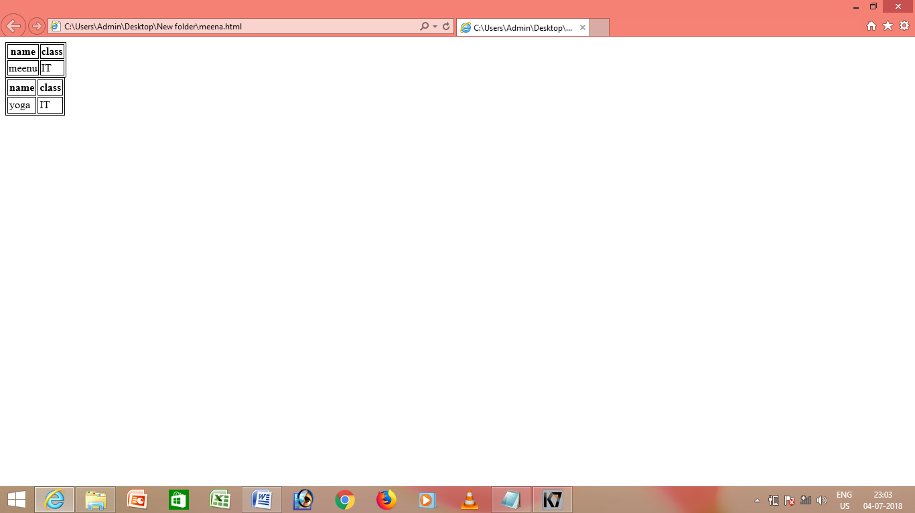

<html>

<head>

<style>

body{

background-color:green;

}

h1{

text-align:center;

}

</style>

</head>

<body>

<h1>internal style sheet </h1>

</body>

</html>

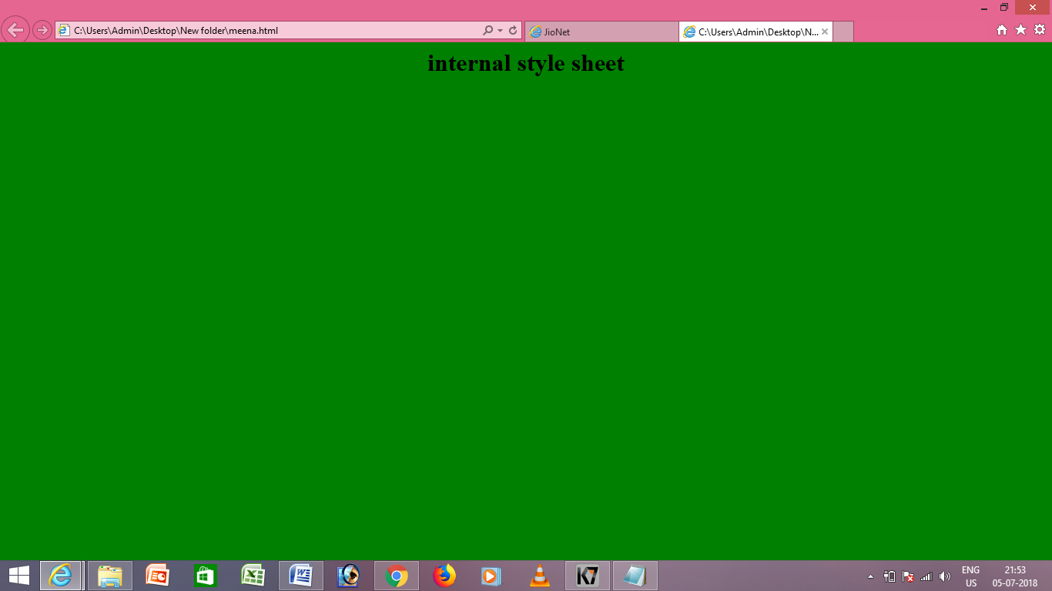

<!DOCTYPE html>

<head>

<link rel="stylesheet" type="txt\css" href="styles.css">

</head>

<body>

<body style=" background-color: blue">

<h1 style="color:white;">the white header </h1>

<p>this is a paragraph</p>

</body>

</html>

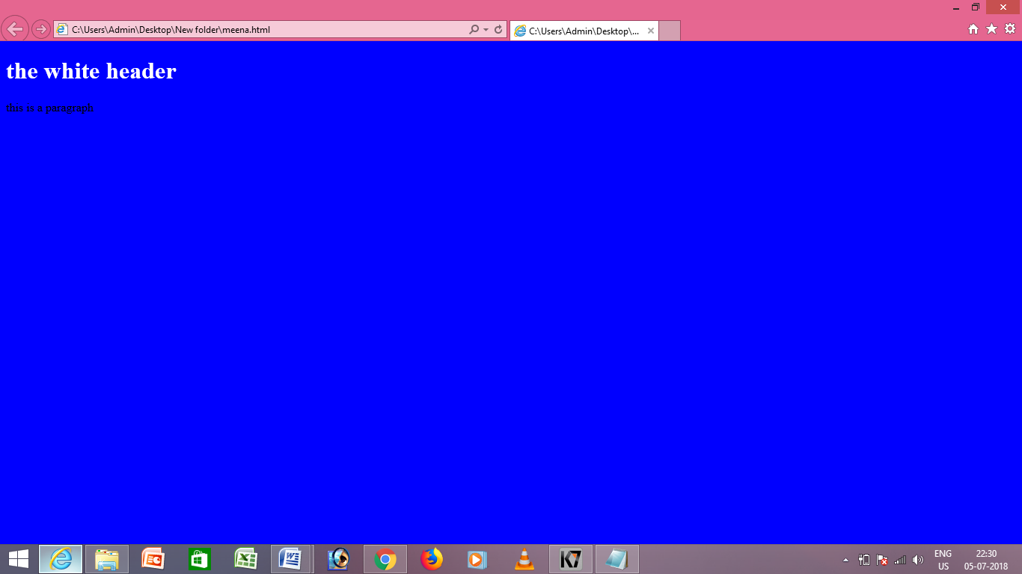

<html>

<body>

<p style="color:red;">a new background and found color in inline css</p>

</body>

</html>

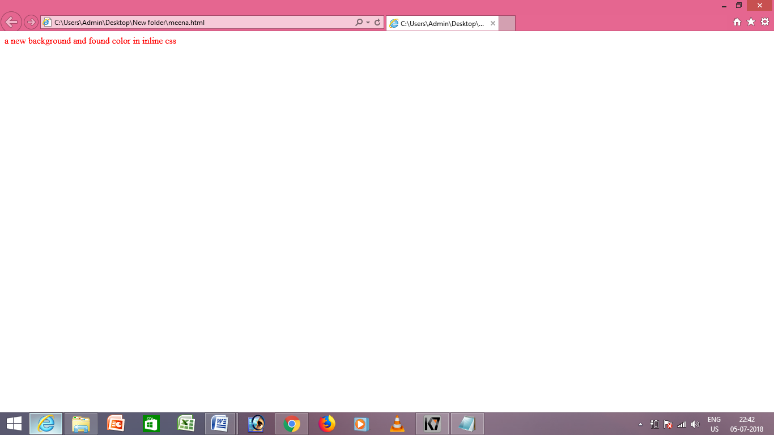

<html>

<body>

<a href="http://www.google.com">google page</a>

<style>

a:link

{

color:red;

}

a:visited

{

color:blue;

}

a:hover

{

color:green;

}

a:active

{

color:black;

}

</style>

</body>

</html>

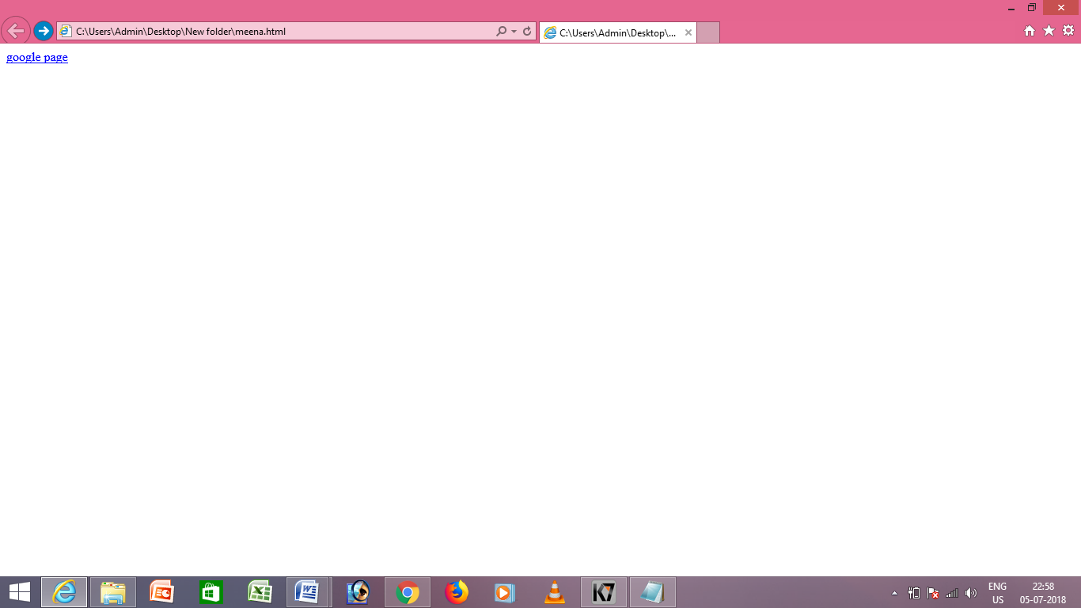

<html>

<body>

<h1>hello</h1>

<style>

body

{

background-color:black;

}

h1

{

color:white;

}

</style>

</body>

</html>



<!DOCTYPE html>

<head>

<style>

h1.serif

{

font-family:"times new roman";

font-style:italic;

font-size:30px;

}

</style>

</head>

<body>

<h1 class="serif">font size specifie the vale of the font</h1>

</body>

</html>

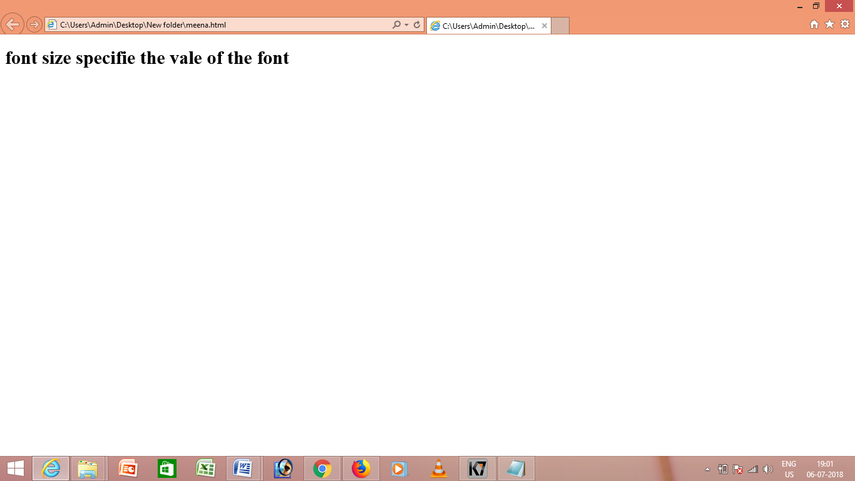

<!DOCTYPE html>

<head>

<style>

h3

{

text-align:right;

text-decoration:underline;

}

</style>

</head>

<body>

<h3>hello how are you</h3>

<h3>hello</h3>

</body>

</html>

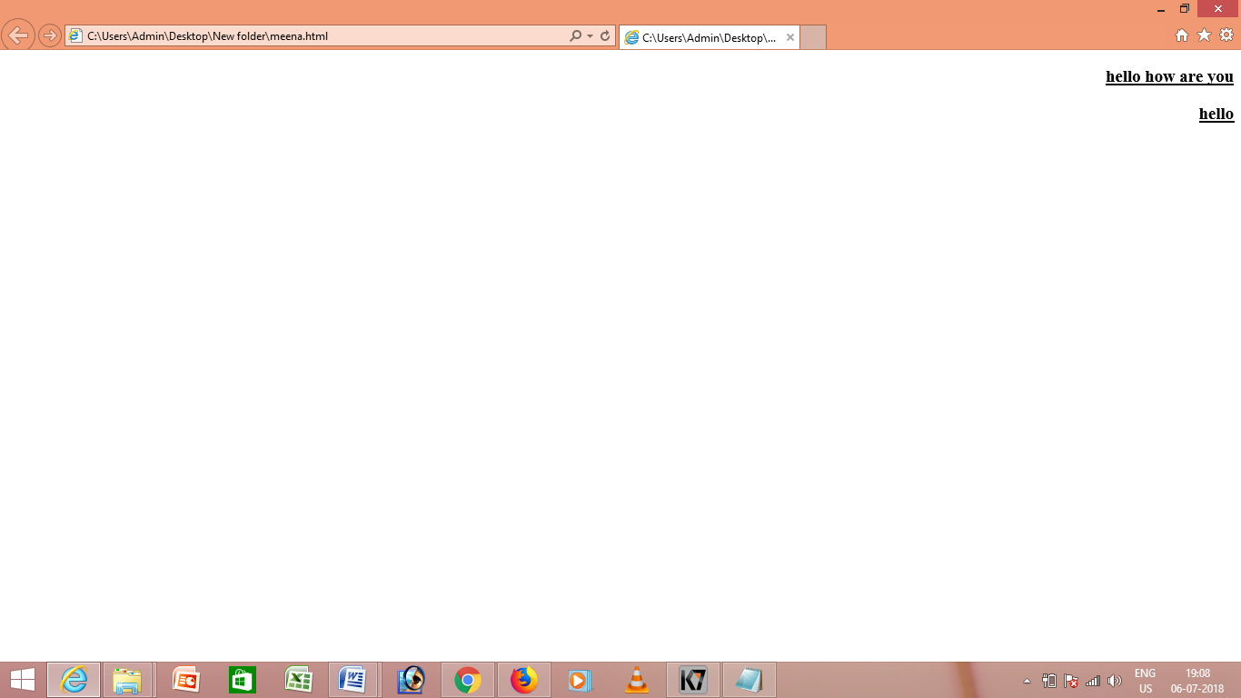

<!DOCTYPE html>

<head>

<style>

div

{

padding: 100px 100px 100px;

border:1px solid black;

}

</style>

</head>

<body>

<div>marginal text</div>

</body>

</html>

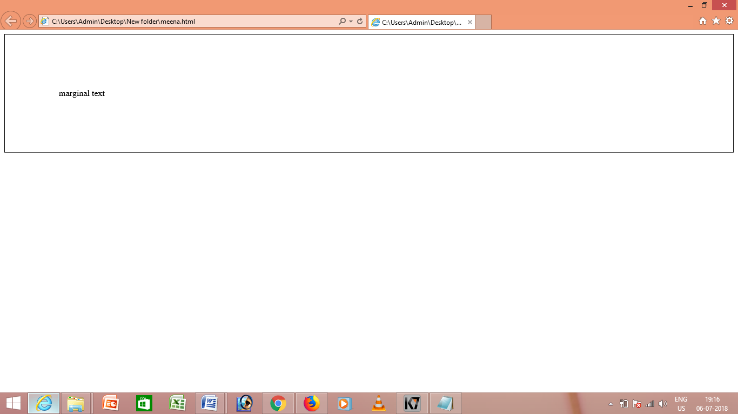

<!DOCTYPE html>

<head>

<style>

div

{

margin: 100px 100px 100px;

border:1px solid black;

}

</style>

</head>

<body>

<div>web pages</div>

</body>

</html>

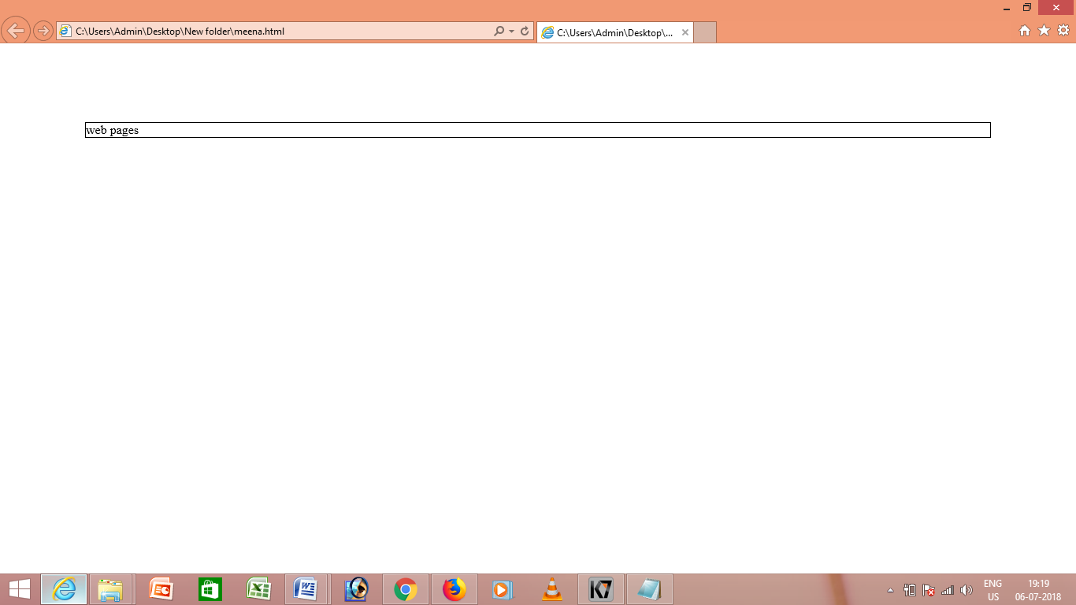

<!DOCTYPE html>

<head>

<style>

div

{

margin: 100px 100px 100px;

border:1px solid black;

}

p {

border-style: dotted;

border-style:double;

}

</style>

</head>

<body>

<div>this paragraph has a black border</div>

<p>the table has an outet border</p>

<p>and each cell has</p>

<p>a dotted border</p>

</body>

</html>

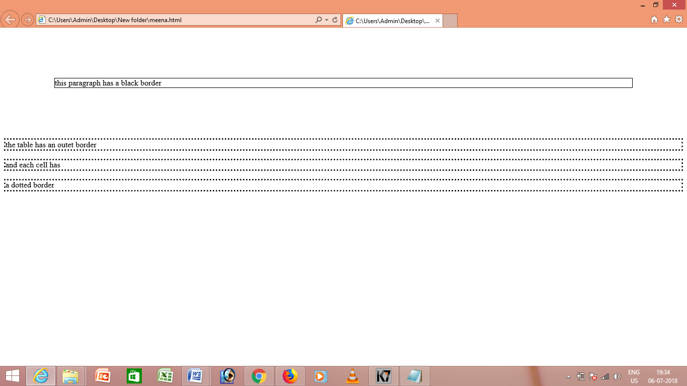

<!DOCTYPE html>

<head>

<style>

ul.a

{

list-style-type:circle;

}

ul.b

{

list-style-type:disc;

}

ol.c

{

list-style-type:numbers;

}

</style>

</head>

<body>

<ul class="a">

<li>grapes</li>

<li> mango</li>

</ul>

<ul class="b">

<li>tea</li>

<li>coffee</li>

</ul>

<ol class="c">

<li>grapes</li>

<li> mango</li>

</ol>

</body>

</html>

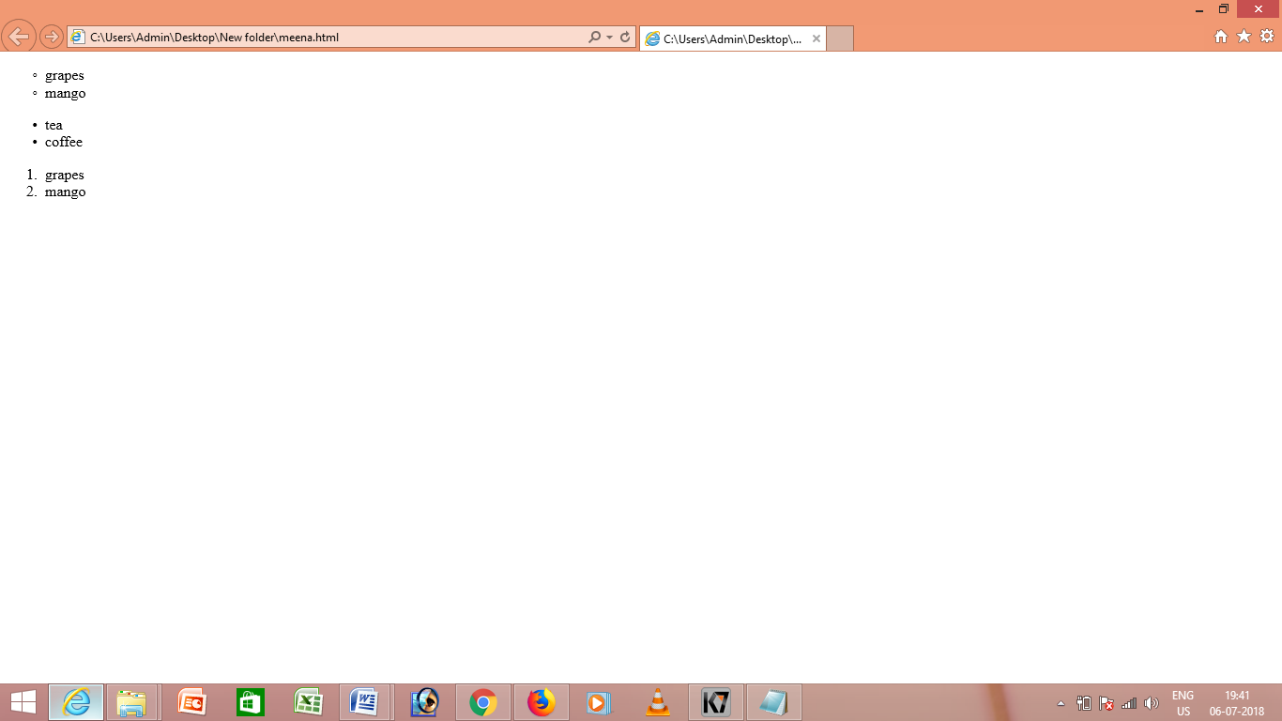

<html>

<body>

<form>

<h1>html form</h1>

name:<input type="text" name="name" value="meena">

</form>

</body>

</html>

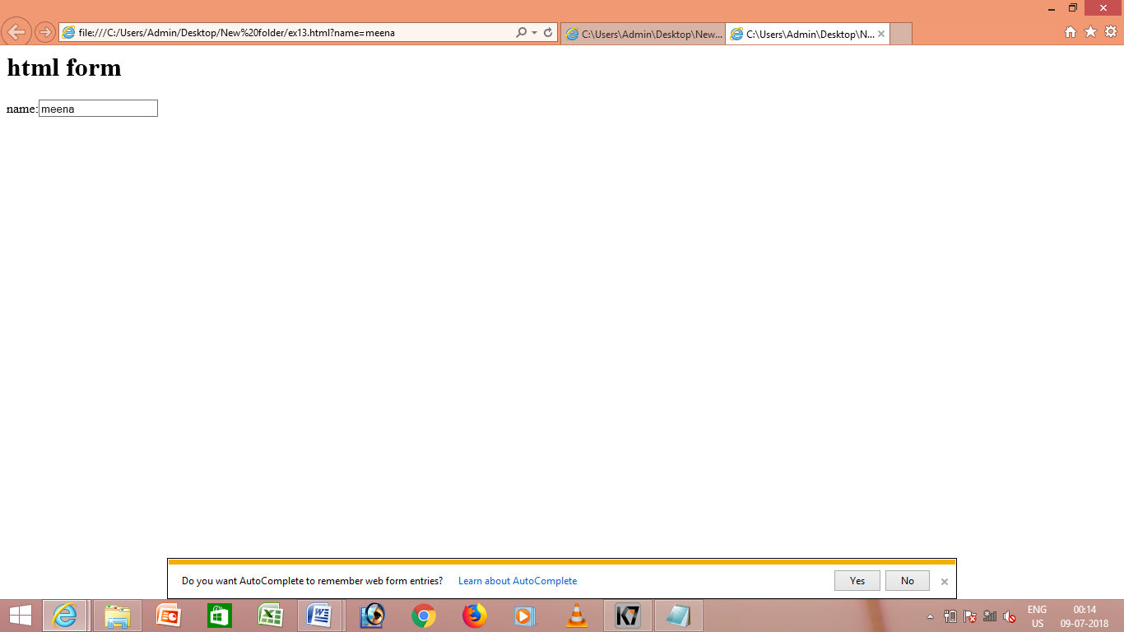

<html>

<body>

<form>

<h1>INPUT</h1>

name:<input type="text" name="name">

</form>

</body>

</html>

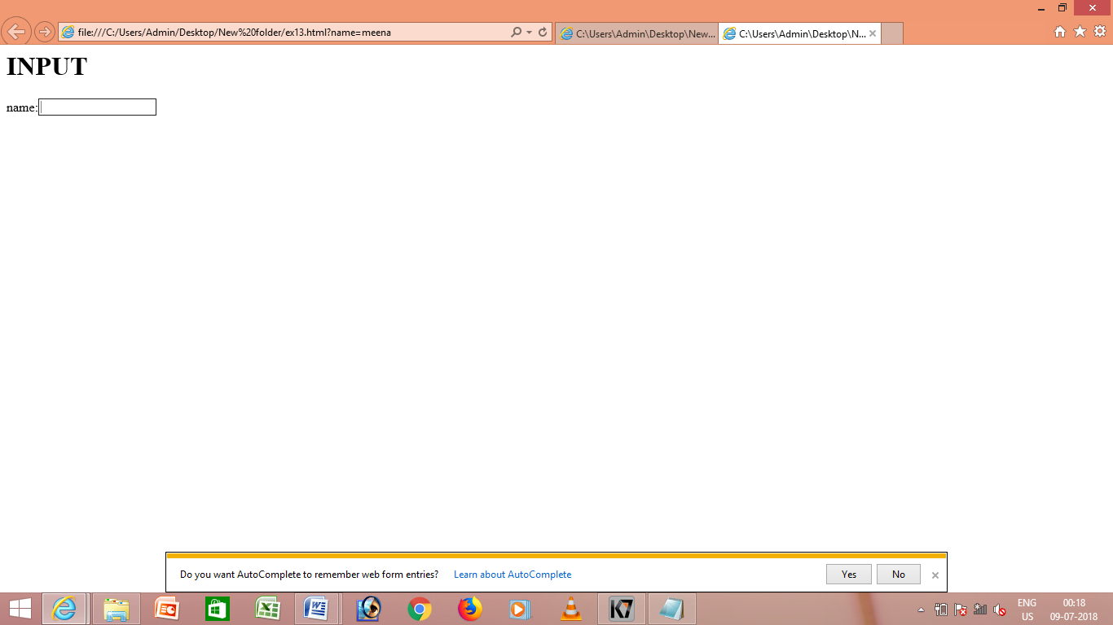

<html>

<body>

<h1>INPUT</h1>

<form>

username

<input type="text" value="ABC"><br>

password

<input type="text" value="x"><br>

</form>

</body>

</html>

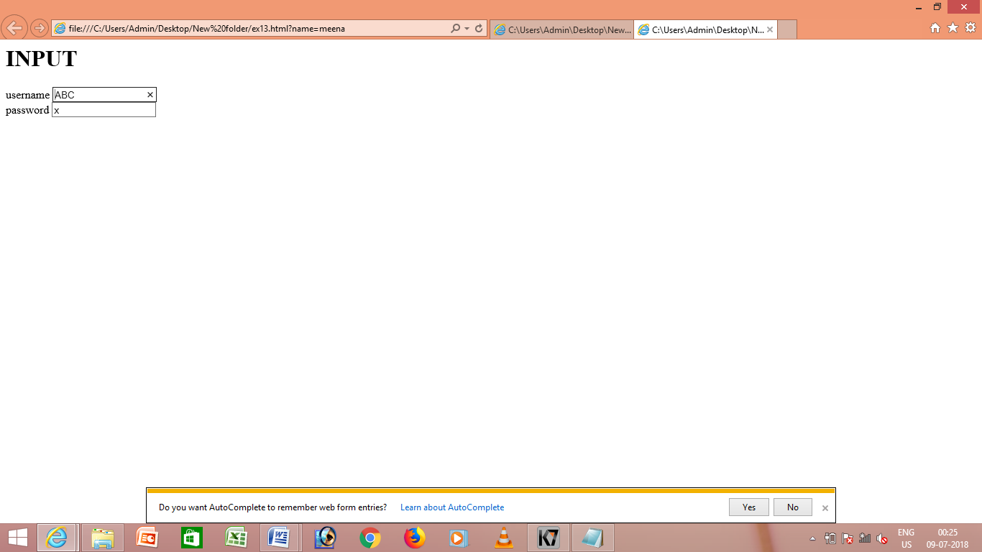

<html>

<body>

<h1>INPUT</h1>

<form>

first:

<input type="text" value="MEENAKSHI"><br>

last:

<input type="text" value="swetha"><br>

password:<input type="password" name="password"><br>

</form>

</body>

</html>

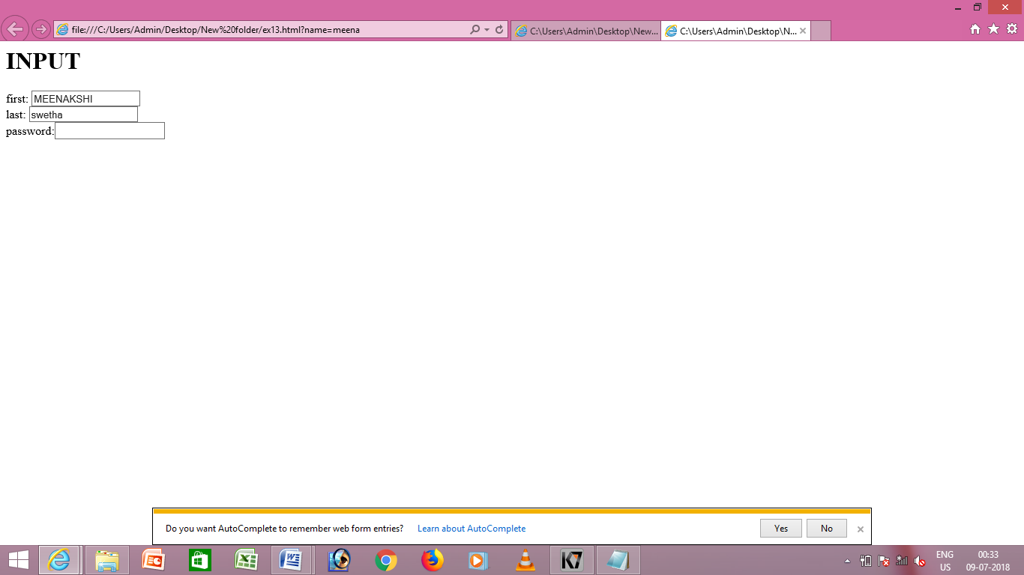

<html>

<body>

<h1>reset</h1>

<form>

username:<input type="text" name="name"><br>

<input type="reset">

</form>

</body>

</html>

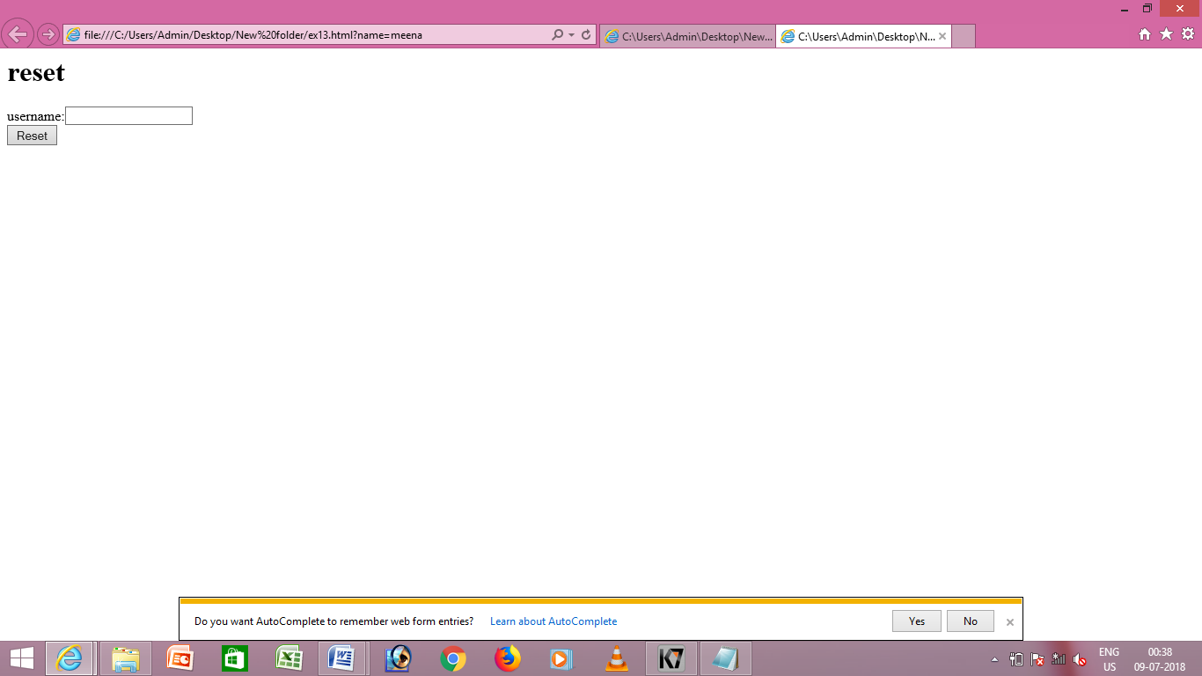

<html>

<body>

<h4>submit</h4>

<form>

first:<input type="text" name="name" value="ABC"><br>

last:<input type="text" name="name" value="ABC"><br>

<input type="button" value="send email">

</form>

</body>

</html>

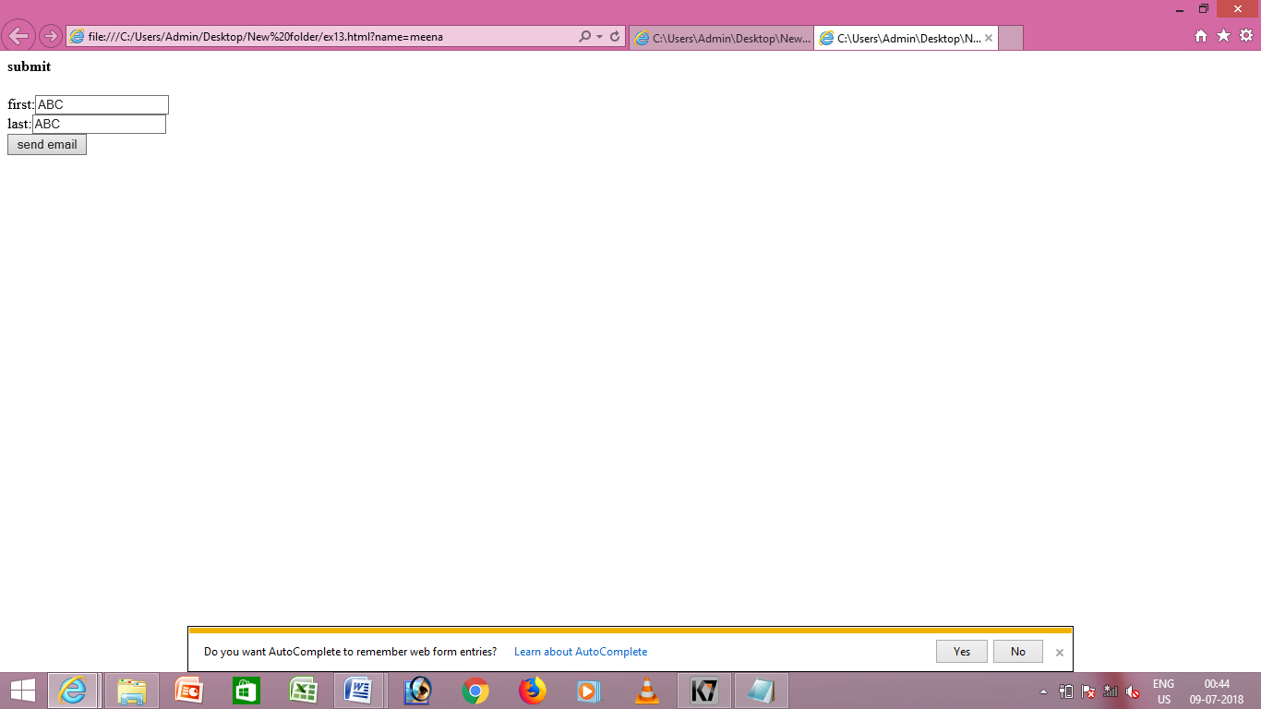

<html>

<body>

<h3>checkbox</h3>

<form>

<input type="checkbox" name="game" value="soccer">soccer</input><br>

<input type="checkbox" name="game" value="football">football</input><br>

<input type="checkbox" name="game" value="basketball">basketball</input><br>

</form>

</body>

</html>

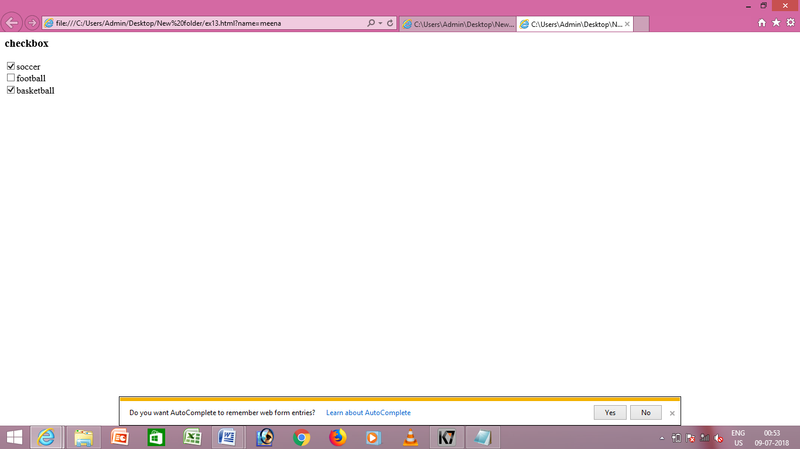

<html>

<body>

<h3>radio button</h3>

<form>

<input type="radio" name="game" value="soccer">soccer</input><br>

<input type="radio" name="game" value="football">football</input><br>

<input type="radio" name="game" value="basketball">basketball</input><br>

</form>

</body>

</html>

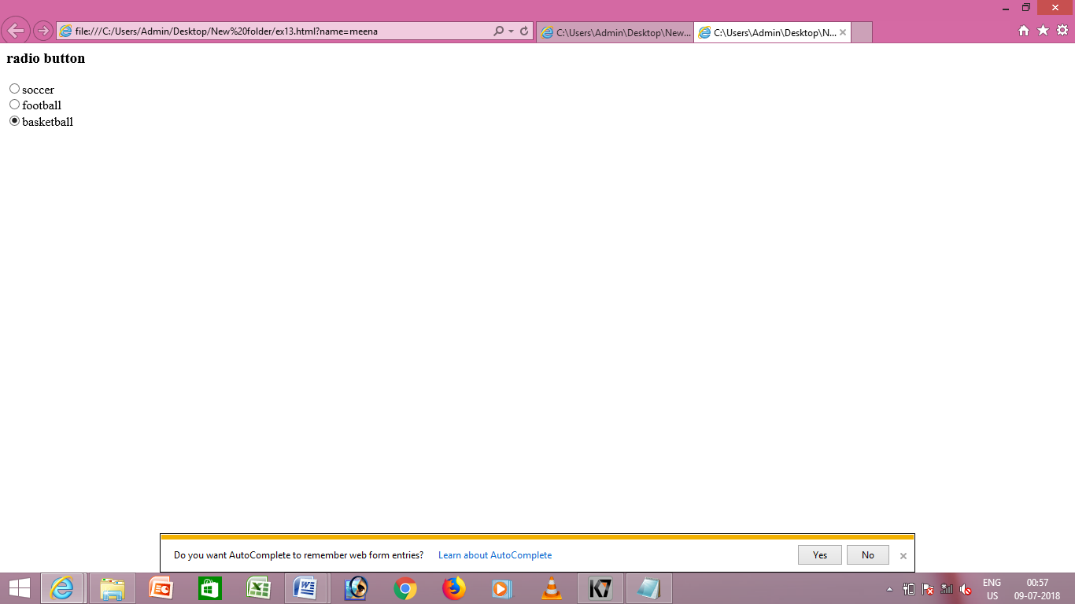

<html>

<body>

<h3>select</h3>

<form>

<select name="states">

<option value="andhra pradesh">andhra pradesh</option><br>

<option value="mumbai">mumbai</option><br>

<option value="kerala">kerala</option><br>

<option value="new delhi">new delhi</option><br>

</form>

</body>

</html>

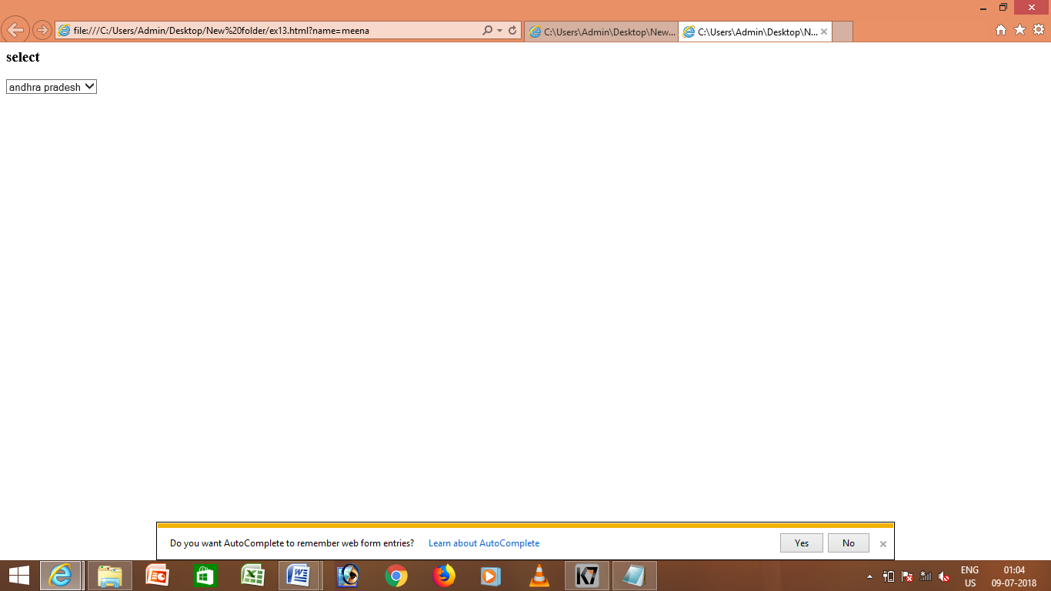

<html>

<body>

<h3>hidden files</h3>

<form>

first:<input type="text" value="MEENAKSHI"><br>

last:<input type="text" value="x"><br>

password:<input type="password" value="password"><br>

<input type="submit" value="submit"><br>

<input type="reset" value="reset"><br>

</form>

</body>

</html>

